

<<Project name>>
Software Design Specification

– Hanoi, August 2022 –

Record of changeS
Date | A*  M, D | In charge | Change Description
*A - Added M - Modified D - Deleted

Table of Contents
I. Overview 4
1. Code Packages 4
2. Database Design 4
a. Database Schema 4
b. Table Description 4
II. Code Designs 5
1. <Feature/Function Name1> 5
a. Class Diagram 5
b. Class Specifications 5
c. Sequence Diagram(s) 5
d. Database queries 6
2. <Feature/Function Name2> 6

I. Overview

1. Code Packages
[Provide the package diagram for each sub-system. The content of this section including the overall package diagram, the explanation, package and class naming conventions in each package. Please see the sample & description table format below (please note: package names don’t follow Java package naming convention yet)]
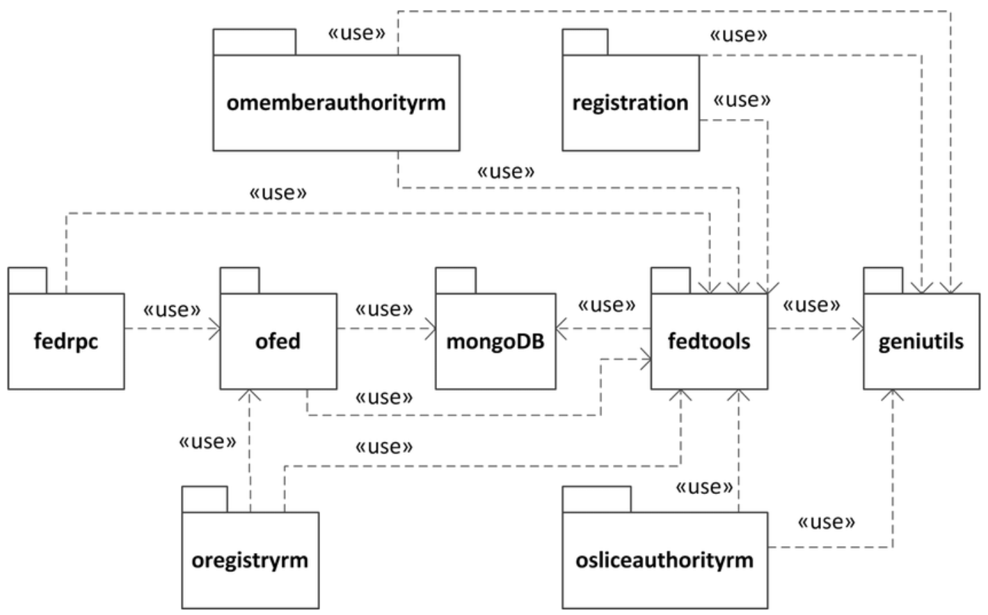
Package descriptions
No | Package | Description
01 | omemberauthorityrm | <Description of the package>
02 | registration | <Description of the package>
03 | fedrpc | <Description of the package>
04 | ofed | <Description of the package>
05 | mongoDB | <Description of the package>
06 | fedtools | <Description of the package>
07 | …

II. Code Designs

1. <Feature/Function Name1>
[Provide the detailed design for the function <Feature/Function Name1>. It include Class Diagram, Class Specifications, and Sequence Diagram(s)]

a. Class Diagram
[This part presents the class diagram for the relevant feature]
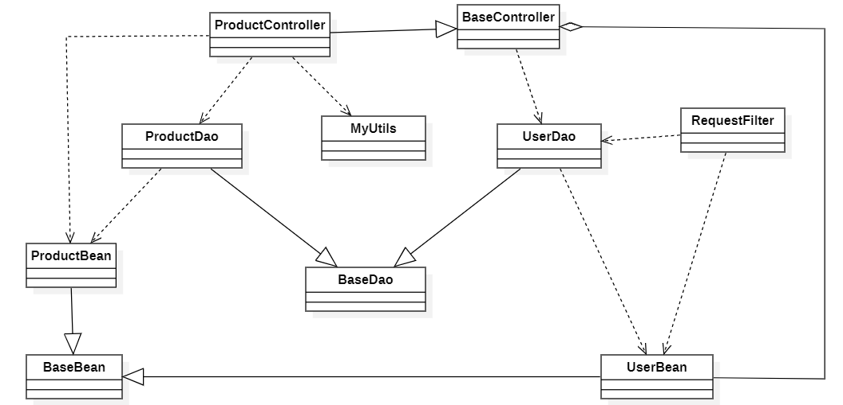

b. Class Specifications
[Provide the description for each class and the methods in each class, following the table format as below]

XYZ Class
[Provide the detailed description for the class methods]
No | Method | Description
01 | <method name> | <Description of the method, including the inputs, outputs & internal method processing>

ABC Class
Class Methods
[Provide the detailed description for the class methods]
No | Method | Description
01 | <method name> | <Description of the method, including the inputs, outputs & internal method processing>

c. Sequence Diagram(s)
[Provide the sequence diagram(s) for the feature, see the sample below]
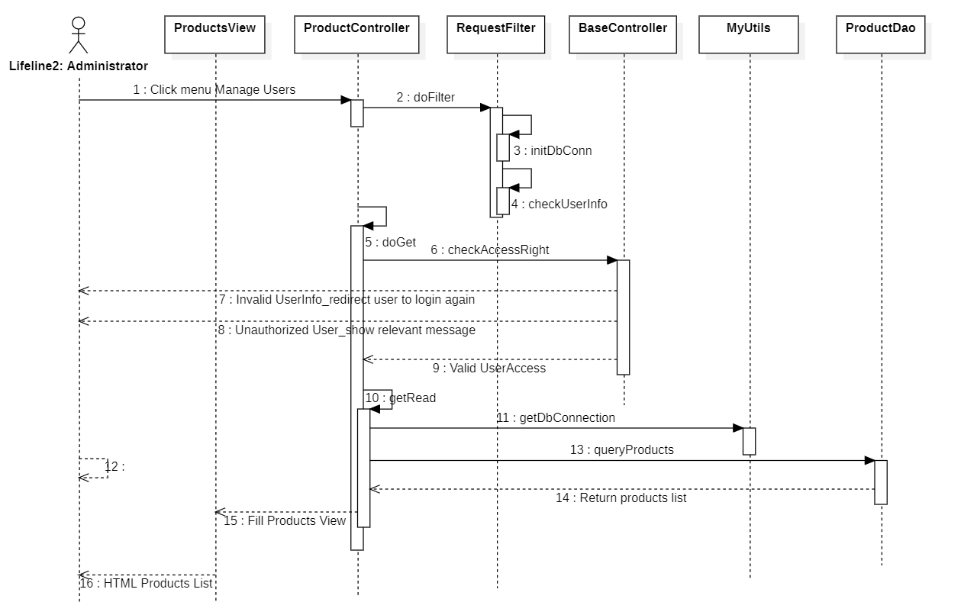

d. Database Queries
[Provide the detailed SQL (select, insert, update...) which are used in implementing the function/screen]

2. <Feature/Function Name2>
…

